Knowledge Organiser – Judy Moody – Girl Detective by Megan McDonald



Quotes
“If a person were going to solve a big fat mystery, she had to have a way-official Nancy Drew detective kit.”

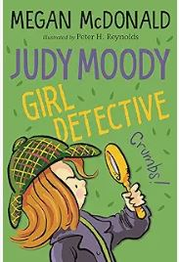
Characters
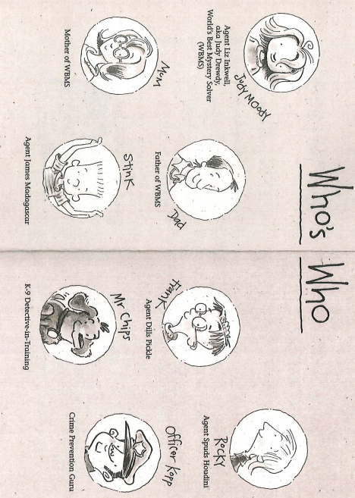
Important Information
Plot – This story is about girl and her friends who work together to solve a mystery about a missing dog.
Themes- mystery, adventure
Setting – school, a town,

Key Vocabulary
detective | A person who solves mysteries
suspicious | something that does not seem right
evidence | A clue or a fact to help prove something
disguise | Items of clothing to make someone look different.
reward | A prize or award
suspect | Someone who might have done a crime

Grammar
Nouns
Adjectives
Suffixes

