PSHE Strand/ Year Group
Changing Me – Year 5
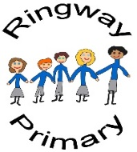
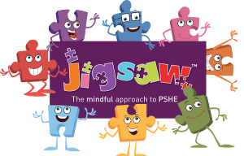
PSHE Knowledge Organiser
Overview
Key Vocabulary
Self image | Boyfriend
Body image | Girlfriend
Confidence | Partner
Compliment | Relationship
Criticism | Attraction
Positive affirmation | Reflection
Puberty | Memory
Changes | Favourite
Mature
Adolescent
To begin the unit, the class will first revise the concepts of self and body image and how both can be impacted in either a positive or negative way though compliments and criticisms. Then, the class will have a chance to reflect on their learning about puberty in our Science lessons as well as write down any further questions they would like to be answered in an anonymous manner. Next, learning will focus around healthy relationships with potential boyfriends and girlfriends encompassing appropriate actions and establishing boundaries. Finally, the class will reflect on their experiences in Year 5 as a whole before considering what they are looking forward to in Year 6.

Social and Emotional Skills
- Can discuss the concepts of self and body image and how this relates to themselves
- Can explain the changes undergone by both boys and girls during puberty
- Can discuss why someone may want to begin a relationship
- Can discuss appropriate boundaries to set in a relationship
- Can reflect on what they have enjoyed/not enjoyed during the year
Knowledge
- I know about the concepts of self and body image
- I know about the changes boys and girls go through during puberty
- I know appropriate reasons for wanting a boyfriend or girlfriend
- I know how to set and communicate clear boundaries within a relationship
- I can reflect on Year 5
- I can explain what I am looking forward to ahead of moving to Year 6

