PSHE Strand/ Year Group
Celebrating Difference – Year 5
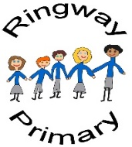
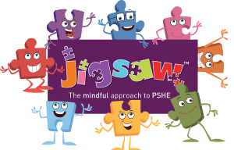
PSHE Knowledge Organiser
Overview
Key Vocabulary
Culture | Bullying
Interests | Physical
Community | Social
Sense of Belonging | Emotional
Similar | Stereotyping
Shared Interests
Racism
Profiling
Rumours
Name calling
First, the class will complete a personal culture wheel in order to gain an understanding of some aspects that underpin culture before comparing and contrasting completes wheels with their peers in class. Then the class will broaden their knowledge of racism through analysing a case studying before considering the impact rumour and name calling may potentially have on wellbeing. Next, the class will learn about the school’s definition of bullying following the STOP model and decide if given behaviours are examples of someone being rude, mean or a bully. Then the class will discuss two further case studies centred around the question: ‘Does money matter?’.

Social and Emotional Skills
- Identify aspects of culture
- Compare and contrast aspects of culture with their peers
- Identify potential actions to combat racism
- Identify potential actions to combat stereotyping
- Continue to develop a more comprehensive understanding of racism and stereotyping
- Discuss the potential impacts of rumour spreading and name calling

Knowledge
- Know what a culture wheel is
- Know some of the different aspects that cane help define culture
- Know about some of the different cultures in our community and around the world
- Know more about varying forms of racism and how to combat it
- Know about the potential impacts of spreading rumours and name calling
- Know the school’s definition of bullying
- Know examples of scenarios of bullying and which actions to take
- Know about stereotyping and which actions to take

