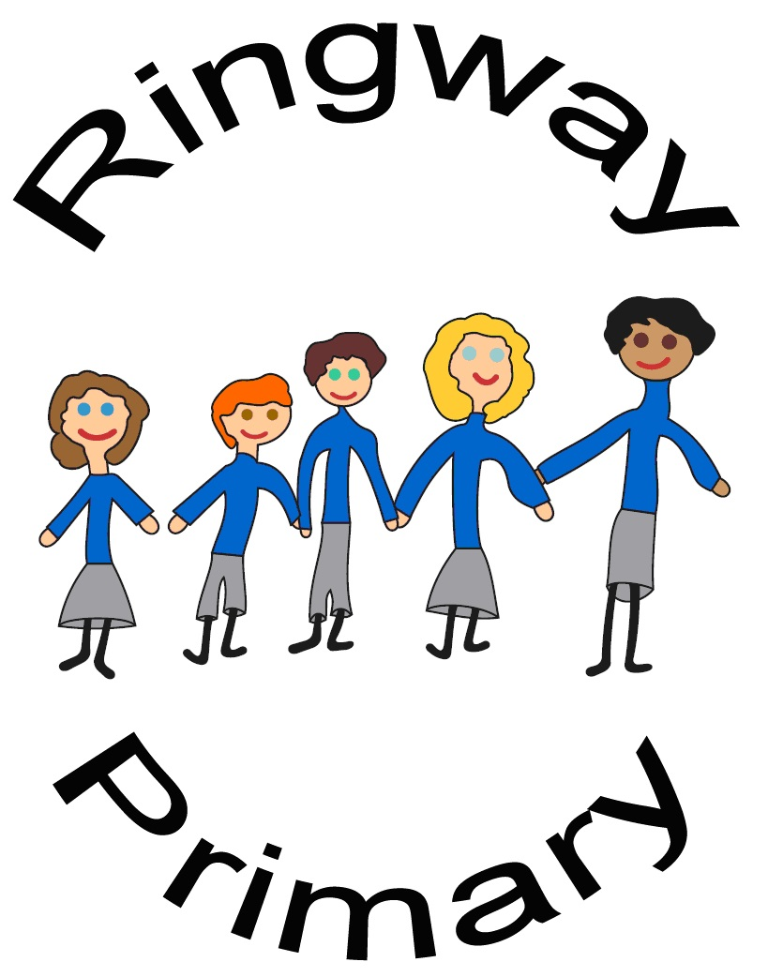

**PE Policy**

**2022/23**

**Ringway Primary School**

**Physical Education Policy and Guidance**

Contents

- Intent, Implementation and Impact

- Introduction and Rationale

- Aims and Objectives

- Provision (curriculum, teaching & learning, assessment & recording, assessing progress, recording & reporting), After School Club Provision

- Equality, Diversity and Accessibility (differentiation)

- Adults Supporting Learning

- Changing Provision

- Safeguarding

- Staff Development

- Leadership and Management

- Monitoring and Evaluation

- Safety Issues (Safe Teaching, Teaching Safely, risk assessment/risk management, pupils’ involvement in, and responsible for, their own safety)

- Clothing and Personal Effects (clothing, jewellery & personal adornment, sensory aids, indoor & outdoor footwear) and Equipment & Resources

Intent

At Ringway Primary School, we understand and value the vital role that high-quality Physical Education plays in the development of physical competence and knowledge of movement and safety, and the ability to use these to effectively perform in a wide range of activities associated with the development of an active and healthy lifestyle. Therefore, our curriculum has been designed to ensure that pupils progressively develop knowledge, skills and techniques before applying said concepts with**creativity**both when planning and performing routines in dance and gymnastics units as well as applying tactical concepts in **collaborative team**games. In P.E. lessons, children routinely demonstrate high levels of **perseverance** and resilience in order to further develop their knowledge and understanding of core concepts. Furthermore, children’s pursuit of **excellence** in a wide range of physical endeavours, and the associated celebration and sense of achievement when children have performed well, compounds the development of **self-belief** which is a central concept in our school’s culture. Where appropriate, P.E. lessons are differentiated, often through the use of formative, assessment for learning (AfL) strategies so that feedback can be both timely, concise and tailored to the needs of the learner; enabling all children to find success in their learning. Finally, the concepts of appropriate sporting conduct and behaving in a **respectful**manner underpin the ethos of P.E. at Ringway Primary School, ensuring that children are able to both celebrate their own successes and appreciate the successes of others in a fitting way. This further allows children to demonstrate core British Values in competitions and performances both in-school and in collaboration with other schools at organised events which promote participation, effort and fair play. Through this intent, we aim for our pupils to develop a love for P.E., find physical activities that capture their interests and passions and support them in sustaining an active and healthy lifestyle.

Implementation:

Our PE curriculum is varied and we have developed long-term plans to ensure that all National Curriculum objectives are covered. All pupils receive at least two hours of high-quality PE per week; through the delivery of one ‘traditional’ PE lesson and one Commando Joes lesson. PE in each year group is sequenced precisely to ensure progression of knowledge and skills and also to ensure that children have the opportunity to experience a wide range of sports, and other physical endeavours, during their time in Primary Education. Children are given the opportunity to further develop their skills in after school clubs that focus on specific sports which are provided by teachers and external coaches. In addition to this, we have extra-curricular after-school clubs which have proven very popular, these clubs include dance and gymnastics as well as a range of indoor and outdoor games.

We have successfully integrated inter and intra sports competitions into the school year, which gives children the opportunity to showcase their skills and enjoy the competitive nature of the sports. In our school, we celebrate our competitions being inclusive and we ensure that all children are involved.

Physical Education is fundamental in developing healthy lifestyles in young people and we are passionate about providing children with a wide range of opportunities to develop this. We recognise the importance of being physically active throughout the day to reduce sedentary learning. We are ensuring all children are active for at least 30 minutes during the school day, and are encouraging children to be active for 60 minutes per day. This is achieved in school by having active break and lunch times, partially led by out UKS2 PE Ambassadors, as well as ‘active learning’ where possible. Break and lunch times are very important and we have well-staffed and equipped playgrounds to support children in being active, healthy, happy and ready to learn when they return to the classroom.

The importance of sport and being physically active in school is continually encouraged by PE Ambassadors. These children are responsible for auditing outdoor equipment, initiating ideas and activities, being a positive role model and encouraging all pupils to get involved in physical activity. This has allowed children to develop their leadership and communication skills to help prepare them for life beyond Ringway Primary School.

Impact:

In our school, we motivate children to participate in a range of sports, games and other physical activities which are fun, engaging and help children to develop a range of skills. We encourage children to apply these skills and their knowledge during PE lessons, but we also provide children with the confidence to apply these skills to many different life experiences both now and in their future. We motivate children to take responsibility for their own health and wellbeing, inspiring children to lead a happy and healthy life.

Introduction

This policy guide has been developed to be used in conjunction with existing resources used at Ringway Primary School to help underpin the effective delivery of an ambitious PE curriculum, and supporting procedures in wider-school life, to high-quality learning experiences for our children.

This policy document outlines guidance in relation to:

* The provision of physical education
* How it is taught and learned
* How it contributes to the physical, cognitive, creative, social and personal development of all pupils. The care, guidance and support of pupils and the framework through which all school leaders, teachers, and other adults supporting learning, understand and manage their roles and responsibilities in the provision of safe practice

All advice and information contained in this policy and guidance, regarding safe practice, is taken from the Association for Physical Education (afPE) handbook on Safe Practice in Physical Education and School Sport, 2012 edition, and Northumberland County Council Health and Safety Policy and Guidance.

Rationale

Physical education is a statutory requirement of the National Curriculum and an essential contributor to the development of the whole child. Through a high-quality physical education programme pupils develop physical competence and confidence and are given opportunities to be physically educated and become physically literate. Through a combination of entitlement and choice of activity, the physical education provision will contribute to the personal development, health and wellbeing, enjoyment, success and achievement of all pupils across the whole curriculum and beyond.

Physical education provides pupils with the opportunity to be creative, competitive and face up to different challenges as individuals and in groups and teams. It promotes positive attitudes towards a healthy and active lifestyle. Pupils learn how to think in different ways and make decisions in response to creative, competitive and challenging activities. They learn how to reflect on their performance, plan, perform and evaluate actions, ideas and performances to improve the quality of their work.

Physical education helps pupils develop personally and socially. They work as individuals, in groups and teams, developing concepts of fairness and of personal and social responsibility.

They take on different roles and responsibilities, including leadership, officiating and coaching.

Through high quality physical education pupils discover their aptitudes, abilities and preferences and make informed choices about how to get involved in lifelong physical activity.

Aims

Through a high-quality, safe and challenging physical education programme, the school aims to develop successful learners, confident individuals and responsible citizens who develop as independent enquirers, creative thinkers, reflective learners, team workers, self-managers and effective participators.

Objectives

* Provide a broad, balanced and relevant curriculum that satisfies the needs of the current National Curriculum and provide pupils with appropriate challenge with acceptable risk.
* Develop a whole school approach to physical development which takes pupils through progressive stages of learning and challenge, enabling them to fulfil their potential, develop competence and control in the gross and fine motor skills that pupils need to take part in PE and sport.
* Educate pupils about, and involve them in, the process of risk management, so that they understand their responsibility in this, in order for them to participate independently in physical activity and to establish good habits and awareness of safety and personal hygiene
* Ensure pupils have the opportunity to demonstrate that they know and understand how to apply their competence and make appropriate decisions for themselves by challenging pupils to select and use skills, tactics and compositional ideas
* Provide pupils with opportunities to use imaginative ways to express and communicate ideas, solve problems and overcome challenges, both as individuals and as part of a team or group
* Ensure pupils understand that PE and sport are an important part of a healthy, active lifestyle and understand the contribution physical activity has on having a healthy body and mind.
* Develop pupils’ stamina, suppleness, strength and the mental capacity (determination and perseverance) to keep going.
* Develop an environment in which pupils have the confidence to get involved in PE and sport and are committed to make it a central part of their lives both in and out of school
* Provide an out of school hours programme of activities which extends and enriches curriculum provision and provides opportunity for activities to enable pupils to make sufficient progress to access curriculum sessions with greater success.
* Provide opportunities for competition appropriate to the stage of the individual pupil’s development
* Ensure that pupils enjoy PE and school sport and establish community links and pathways for pupils to engage in life-long participation.
* Provide links to other areas of the curriculum and wider school, county and national agendas.

Curriculum

All pupils are entitled to a progressive and comprehensive physical education programme which embraces current Statutory Orders of the National Curriculum and takes into account individual interests and needs.

Pupils should have access to all components of current National Curriculum programmes of study, which should include developing fundamental movement and basic skills in a broad range of activities in both KS1 and KS2 so that a realistic attempt is made to achieve the expected levels of performance.

The planning and delivery of each unit of work will ensure that each pupil will have the opportunity to:

* Acquire and develop new skills
* Select and apply appropriate skills, tactics and compositional ideas
* Evaluate their own and others’ performance in order to improve
* Gain knowledge and understanding of how PE and sport contributes to staying physically, mentally and emotionally healthy
* Experience a range of roles – performer/coach/official/leader etc
* Planning will provide opportunities to link with other areas of the curriculum e.g. Computing, literacy, numeracy and PSHE

Teaching and Learning

* Lessons will be planned to provide appropriate challenge for all pupils, including those in need of a greater level of support and the more able, and provide appropriate levels of support in order for all pupils to make progress.
* The learning environment will enable all pupils to recognise their own and others’ strengths and areas for improvement and provide them with appropriate tasks to improve and succeed.
* Lessons will provide appropriate activities which enable pupils to develop as independent enquirers, creative thinkers, reflective learners, team workers, self-managers and effective participators.

Assessment & Recording

The attainment target for physical education sets out the knowledge, skills and understanding that pupils of different abilities and maturities are expected to have by the end of each key stage.

Teachers should ensure that when evaluating and improving performance, connections are made between acquiring, developing, selecting and applying skills, evaluating and improving performance as well as demonstrating a knowledge and understanding of health and fitness and performance in different roles

Refer to National Curriculum documentation for details relating to physical education strands

The expected attainment for the majority of pupils at the end of each phase (EYFS, KS1, LKS2 and UKS2) is summarised in the Northumberland County Council Progression of Skills resource.

Assessing Progress

To assist in formative assessment, teachers could use the following:

* Ringway Primary School Progression of Skills sheets and reflection questions outlined in planning to involve pupils in self and peer assessment, helping them understand where they are at the beginning of a unit of work, and identify what they need to do to make progress.
* Assessment documents linked to the class’ unit of learning sourced from Get Set 4 PE (the approach to PE which underpins the vast majority of PE planning).
* Watch children work, talk to them about what they are doing and listen to them describe their work.
* Receive feedback from pupils to inform teachers and pupils of what has been successful and allow them to set their own future targets.
* Use the 10 outcomes of high quality as outlined by the Association for PE (AfPE).

Recording & Reporting

Records are selective and brief and teachers should have a clear reason for recording information. Significant achievements or weaknesses may be noted on an evaluation of the lesson, as well as a formative assessment of each child’s progress in a lesson contributing to an overall assessment at the conclusion of each learning sequence, and used to:

* Inform future planning for themselves or a new class teacher
* Form part of the statutory annual reporting process, and in discussions with parents
* Help children as a basis for future target setting
* Inform during transfer between classes and key stages to ensure continuity of progression

After School Club Provision

At Ringway Primary School, we strive to provide a range of appropriate and engaging after school clubs to encourage children to be active for at least 30 minutes throughout the school day. Clubs are provided by both Ringway staff and through our existing relationships with outside providers, including: The Newcastle United Foundation and All-Star Dance Productions.

Equality, Diversity and Accessibility

All pupils can access a broad and balanced PE curriculum, which meets the specific needs of individuals and groups of pupils, including those who have diverse special educational needs, disabilities, gifted and talented pupils and those who have English as an additional language.

Lesson planning, delivery and assessment ensures that pupils are provided with appropriate and effective opportunities to actively participate and succeed in the whole range of learning opportunities offered within and outside the curriculum.

The needs of individuals are met by providing dedicated support staff, a range of equipment, appropriate groupings, safe spaces in which to work and differentiated tasks which enable all pupils to make progress.

Differentiation

Planning for differentiation should be based on the S.T.E.P. principles i.e. making changes to SPACE, TASK/TIME, EQUIPMENT and PEOPLE taking account of:

* The size of the area in which a pupil works, smaller spaces until pupils develop spatial awareness and control over themselves and equipment, larger spaces to challenge more-able pupils.
* Pupil activity, e.g. different task, different roles and responsibilities, different allocations of time and variations of pace within the lesson to meet needs of different levels of ability.
* Resources, e.g. different equipment for different levels of ability across the key stages.
* Pupil groupings, e.g. ability or mixed ability groups; or group, paired or individual activities, the opportunity to work with adult support where needed
* Other opportunities, e.g. extracurricular activities, club links and interest groups, for the development of excellence.

Adults Supporting Learning (ASL)

ASL include classroom assistants, teaching assistants, HLTA, learning mentors, visiting coaches and sports apprentices but not trainee teachers.

Additional support staff will be used during curriculum and non-curriculum time in order to:

* Support the delivery of high-quality PE
* Enrich or enhance an activity pupils are undertaking
* Provide training opportunities for staff
* Provide additional opportunities for OSHL
* Contribute to any LA or SSP developments e.g. support the School Games Framework

All ASL and coaches will receive appropriate access to School, LA and SSP training and support to ensure their knowledge and understanding of delivering curriculum PE is in line with current statutory requirements and recommended good practice.

The head teacher will always maintain responsibility for safe recruitment procedures, disclosure certification, possession of a governing body of sport licence, where relevant, and confirming authenticity of all ASL and coaches

Head teachers are advised to accept a Level 2 award as the normal baseline qualification for each activity the coach is expected to teach, diverting from this standard only if the coach is observed prior to acceptance and demonstrates good coaching qualities and is working towards a Level 2 qualification where appropriate

The class teacher will always maintain overall responsibility for what is taught and the conduct, health and well-being of the pupils.

No ASL should operate independently. They may work alone if competence has been monitored but will be managed effectively by the teacher, who remains legally responsible for the students in their care, whether through direct or indirect supervision of the ASL.

Changing Provision

Typically, children will not need to change their clothes for a PE lesson on the school-site as children are asked to come into school wearing appropriate PE kit on the day of their PE lessons. Dignity, decency and privacy, where needed, will be maintained when children need to get changed before PE lessons. The following will be taken into consideration when deciding the necessity of constant direct, intermittent direct or distant supervision:

* Age of the pupils
* Joint gender
* Behavioural issues
* Potential bullying
* Location of staff
* Safety aspects of the changing space

Safeguarding

At all times, all staff, both those employed by Ringway Primary School and those from outside agencies, must adhere to our stringent safeguarding procedures and report any potential concerns or incidents using the systems in place.

Staff Development

Opportunities for the development of all staff should be provided in order to enhance the quality of PE within the school. The needs of the staff will be identified through the monitoring and evaluation of the subject which is undertaken by the designated Subject Leader and should be done in conjunction with the whole school development plan. The Subject Leader should ensure that all teaching staff, ASLs and coaches are aware of the development opportunities available from the Education Development Service, School Sports Partnerships and other partners. The subject leader will ensure that any development opportunities undertaken by staff are disseminated throughout the school where necessary to further enhance the quality of PE.

Leadership & Management

The Subject Leader is responsible to the Head Teacher and will ensure that the following points associated with the role are considered and carried out where appropriate:

* Developing good classroom practice.
* Managing the budget (sports premium) based on the needs identified through the monitoring and evaluation of the subject and the whole school development plan.
* Reporting on the allocation of the sports premium and its impact on the school website.
* Auditing, ordering and reviewing efficiency of how equipment, learning resources and accommodation are managed to ensure pupils are well taught and protected.
* Accessing any funding available that may enhance the quality of PE within the school.
* Attending courses to further own professional development and providing information and support for colleagues.
* Monitoring classroom practice and planning, auditing needs for CPD to ensure high quality delivery and setting future targets.
* Make all resources available to all staff, including policy, schemes of work, assessment materials, resources to support learning.
* Carry out risk assessments in line with local authority procedures.
* Extending relationships and contacts beyond the school and in the local community.
* Keeping up to date with and implementing any National, Local Authority and School Sport Partnership developments where appropriate.

Monitoring & Evaluating

Subject monitoring and evaluating will be carried out by the Subject Leader with support from the SLT where appropriate. The school will utilise the following strategies and measures in order to evaluate standards in PE.

* Observation of teaching and learning, including support staff and coaches, to assist in the identification of strengths and development needs.
* Assessment of pupil progress and achievement
* Pupil interviews
* Self-evaluation of the subject in relation to the 10 high quality outcomes for PE.
* The opportunity SSP high quality sampling visit

Safety Issues – Safe Teaching, Teaching Safety

Safe Practice in Physical Education & School Sport (AfPE 2012 edition) is a comprehensive guide to safe practice and managing risk in PE and should be referred to regarding any aspect of Health & Safety

The PE policy is in line with school, EDS and NCC guidance. The subject leader should work alongside any staff responsible for health and safety within school. Any policy must be agreed by staff and approved by the head teacher and governors.

Risk Assessment/Managing Risk

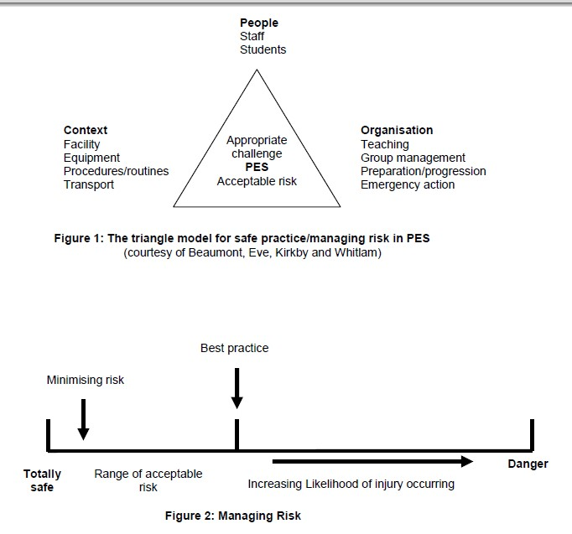

The importance of safety in PE is stressed immediately pupils enter the school and pupils are continually reminded of the need to look after themselves and others whenever they are participating in PE, sport or playing in the playground. Planning includes opportunities for explicit teaching of safe practice, particularly in potentially dangerous areas like the swimming pool, gymnastics hall and playground.

Teachers and pupils help to identify possible hazards in lessons. Teachers discuss with pupils how much risk the hazard is and what can be done to reduce the risk so nobody gets harmed.

This process of risk control is reinforced in the classroom through the production of posters that can be pinned to the wall to highlight these dangers.

All PE equipment is checked during:

* The annual health and safety check of school and equipment carried out by the governing body.
* Sport and Play annual inspection of all PE equipment.
* Regular risk assessments of the school carried out by the school caretaker.

Any significant risks will be reported to the head teacher. Teachers are also encouraged to carry out informal risk assessments prior to every PE lesson. This will involve a quick overview of the teaching environment and equipment which is then matched with the planned lesson content to assess whether it is safe to proceed or use an alternative approach.

In summary, schools should consider the following process:

* Decide what requires a risk assessment
* Identify the hazard – anything that can cause harm
* Decide who is at risk
* Evaluate the risk
* Record the findings
* Devise control measures to minimise the risk (risk management)
* Inform those affected
* Periodically review the assessment

Pupils’ involvement in, and responsibility for, their own safety

From the youngest age, pupils will be encouraged to look around them and identify what they perceive could harm them. Continuously, the teacher needs to identify general considerations and question with the pupils, whether a situation is safe and what considerations have been addressed. The pupils will have learning experiences, appropriate to their age, that enable them to plan and manage their own activities safely. These will, of course, be managed remotely by the teacher who maintains duty of care.

Pupils will be made aware that chewing and eating during an activity is not acceptable.

Refer to Section 4 in Association for Physical Education (afPE) handbook on Safe Practice in Physical Education and School Sport, 2012 edition.

Clothing & Personal Effects – (AfPE recommendations)

Introduction

* Clothing and correct attire for a particular activity represent important features of safe practice that apply in equal measures to both staff and pupils.
* Staff should always endeavour to change for physical education, wear suitable footwear and clothing for practical activities and remove their personal effects, such as jewellery, to minimise the likelihood of causing or receiving injury.
* Pupils should arrive at school wearing the appropriate PE kit, following clear communication from the teacher responsible for the class’ lesson, on the day of their PE lesson.
* Clothing for PE and school sport should be well suited to its function. It should be light and allow good freedom of movement, but will also need to offer some insulation from cold weather in the winter months. It should be remembered that pupils who are insufficiently warm and experiencing discomfort will not be sufficiently focused and may lack concentration.
* Footwear that is fit for purpose is essential. It should demonstrate effective grip, support and reasonable protection for outside work and games, contrasting with lightness and flimsiness for indoor activities such as gymnastics and dance, if worn.
* Personal effects, such as jewellery, religious artefacts, watches, hair slides etc, should always be removed by pupils before participating in physical activity.
* Staff also need to be mindful of their own adornments. The wearing of rings for instance, has been responsible for unnecessary injury in the past and represents a hazard to both staff and pupils involved in the lesson. Any exception to the recommendation of complete removal needs to be carefully considered and always comply with a suitable risk assessment. Children MUST remove earrings or cover with plasters if unable to be removed. Before gymnastics lessons, all children MUST remove earrings or they will have to take on a non-participant role in the lesson.
* Clear expectations should be established throughout the school and with parents, about the management of personal effects.

Jewellery and personal adornment

* The wearing of non-essential personal effects continues to pose difficulties in many schools since such items should ideally, always be removed in establishing as safe working environment. Staff have a duty of care to ensure that pupils are able to actively participate without unnecessarily endangering themselves or those working around them. Systems and procedures need to be in place within the changing area to check that pupils fulfil this obligation prior to participation.

The following procedure should be applied at the start of every lesson:

1. All personal effects should be removed. Staff should always give a verbal reminder to pupils and, where necessary, visually monitor the group. Particular vigilance may be required when dealing with body jewellery.

2. If they cannot be removed, e.g. medical bracelets/necklaces, staff need to take action to try to make the situation safe. In some situations, this may mean adjusting the activity in some way or, where a risk assessment allows, protecting the item with tape, padding or wristband. Taping over ear studs, for instance may offer a measure of protection in some physical activity situations where individuals are required to work within their own personal space. The amount of tape needs to be sufficient to prevent the stud post penetrating the bone behind the ear should an unintentional blow be received from someone or a piece of equipment. This would not be acceptable, however, in swimming lessons where exposure to water can easily dislodge the tape, magnifying the hazards involved, nor is it satisfactory in situations where close contact is foreseeable. Where taping is utilised, the adult supervising the group maintains the duty of care to ensure that the taping is effective in its purpose.

3. If the situation cannot be made safe, the individual pupil(s) concerned should not actively participate. Alternative involvement in the lesson may be possible.

The wearing of spectacles or hearing aids will usually be determined by:

1. The nature of the activity
2. A balanced judgement as to whether wearing the item constitutes a greater or lesser risk to the wearer in those activities where physical contact is absent

Where sensory aids need to be worn for safe participation by the individual then the staff need to apply the procedure set out above in order to determine whether participation with the sensory aid is safe for the wearer and for the others in the group.

Long hair worn by both staff and pupils should always be tied back with a suitably soft item to prevent entanglement in apparatus and to prevent obscuring vision.

Footwear

* Suitable footwear is crucial to safe participation and supervision. Security of footing is essential. Staff may need to respond quickly to prevent a potential injury to a pupil, making effective mobility essential. Pupils need footwear that is capable of transmitting feel for the movement and the surface they are working on.
* Many practitioners believe that bare feet offer a better alternative for indoor activities such as gymnastics and dance (unless movement includes e.g. lots of skipping actions), providing the floor is of good quality and clean. Where any doubt exists about the suitability of the working surface, however, appropriate footwear becomes a requirement.
* Pupils should never participate in socks on polished surfaces. Well-fitting socks maybe applicable on a carpet surface if traction is not affected.
* Training shoes on which the soles provide good traction, will often prove effective for a range of indoor games, but should not be worn for gymnastics activities for the reason of feel described above.
* Some form of footwear is preferable for indoor games activities due to the higher frequency of sudden stopping and changing direction quickly.
* Staff need to avoid situations often found in games lessons when organising wet weather indoor activity in which some pupils wear training shoes and others are obliged to resort to bare feet.

Pupils should know that:

* Clothing used for PE and school sport should be suitable for the activity and designed with safe participation in mind.
* Personal items of physical education and sports clothing should be kept clean and serviceable.
* Physical education and sports footwear should be regularly checked and well maintained.
* Jewellery should always be removed before active participation; any exception to this rule must always be sanctioned by a member of staff.

Equipment & Resources

The majority of PE equipment is stored in the sheds location on the KS2 yard, with the exception of smaller equipment, which is kept in the PE cupboard in the LKS2 corridor. All equipment is catalogued and a list is available from the PE coordinator. The equipment suitability is reviewed to ensure it is appropriate to the range of ages, abilities and needs of children in order to enhance learning.

Pupils are encouraged to:

1. Look after resources.
2. Use different resources to promote learning.
3. Return all resources tidily and to the correct place (Staff to supervise).
4. Be told of any safety procedures relating to the carrying or handling of resources.

Policy review and update

Last reviewed: March 2023

Date of next review: March 2024