Quote
“These powerful stories are brought to a young modern audience with a verve and simplicity that makes them shine in our minds.” Michael Rosen
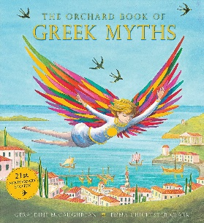
Knowledge Organiser – The Orchard Book of Greek Myths

Characters
Ancient Greek Gods | A range of Ancient Greek Gods are prominent characters in many myths
Heracles | A demi-god (half God-half human) who is tasked with completing twelve outlandish labours
Daedalus | A genius inventor imprisoned on Crete by the wicked King Minos
Theseus | The hero of Athens tasked with slaying a monstrous beast
King Midas | A power-hungry kind cursed to make everything he touches turns to gold
Important Information
Plot You will discover the drama and the thrill of sixteen classic Ancient Greek myths during this half-term. The myths we will read are: Theseus and the Minotaur, Pandora’s Box, Perseus and Medusa, Jason and the Golden Fleece, Daedalus and Icarus, Orpheus and Eurydice, Arachne, The Wooden Horse of Troy, King Midas, Persephone and the Pomegranate Seeds, Echo and Narcissus, The Twelve Labours of Heracles, Odysseus, Apollo and Daphne, Atalanta’s Race and Freedom for Prometheus.

Themes Human flaws. Paying respect to the Gods. Brains over brawn (including cunning and trickery). Temptation. War. Love. Fate. Beauty. Payback and Reward.
Setting Numerous setting (both real and fictional in the Ancient Greek World) including: The Palace of Knossos and the island of Crete, Mount Olympus, great cities including Athens, Corinth and Troy as well as the Greek Underworld.

Key Vocabulary
Pantheon | A group of particularly well known and respected Gods
Mount Olympus | A mountain in Greece that’s peak was believed to be the home of the Greek Gods
Olympians | The most powerful Greek Gods who lived atop Mount Olympus
Labours | A series of extremely demanding tasks to be completed by Heracles in order to earn forgiveness
River Styx | The main river of the underworld sailed by Charon
Tribute | An act, statement or gift that is intended to show gratitude
Grammar
Verbs and Verb Tenses
Making sure the verbs agrees
Checking verb tense in writing
What is a modal verb?
Writing with modal verbs and adverbs
Adverbs
Verbs in writing
