Quote
“A witch never gets caught. Don’t forget that she has magic in her fingers and devilry dancing in her blood.”
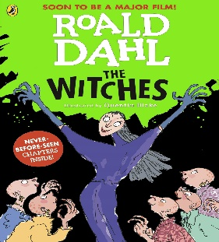
Knowledge Organiser – The Witches

Characters
Boy | Our unnamed main character
Grandmamma | His fierce, loving grandmother
The Grand High Witch | The leader of witches worldwide
Bruno Jenkins | A rather greedy boy staying at The Hotel Magnificent
Mr and Mrs Jenkins | Bruno’s parents
Important Information
Plot After being orphaned; Boy goes to live with his Grandmother who tells him lots of stories about Witches. In order to improve her health, Grandmother and Boy are forced to take a holiday to a hotel on the English coast where he is accidentally locked in a room with over 200 witches and finds out about their wicked plan using Delayed-Action Mouse Maker…

Themes Gender, children and childhood, belief, beauty and ugliness, death and loss, religion and national identity.

Setting Norway, England and The Hotel Magnificent.

Key Vocabulary
Absurdity | The quality of being stupid and unreasonable
Quirky | Unusual in an attractive or interesting way
Conviction | A firmly held belief or opinion
Ruse | An action intended to deceive someone; a trick
Morsel | A small piece or amount of food
Wizened | Shrivelled or wrinkled with age
Repellent | Able to repeal a particular thing or something causing disgust
Gape | Stare with one’s mouth open wide in wonder and amazement
Grammar
Words at work
Word classes
Changing noun and adjectives into verbs
Verbs
Verb prefixes
Expanding noun phrases
Making words work
