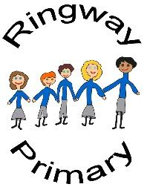

Knowledge Organiser – A Ticket to Kalamazoo; Poetry

|  |
| --- |
| Zippy Poems to Read Out Loud |

|  |
| --- |
| Key Vocabulary |
| Rhyme | Words with endings that sound the same e.g. moon, June. |
| Timbuktu | A city in Africa. |
| bobbing | To move up and down. |
| scoffed | To eat something quickly. |
| re-energise | To get energy back again. |
| grotty | Something that is unpleasant. |
| gnashers | A slang word for teeth. |
| Grammar |  |
| Punctuation – Full stops | . |
| Punctuation – Question mark | ? |
| Punctuation – Capital letter | A |
| Punctuation – Ellipsis | … |

|  |
| --- |
| Types of Poem |
| Rhyming – a poem with pairs or groups of words which make the same sounds. |
| Riddle – a poem with clues to solve to find the answer. |
| Acrostic – the first letter of each line forms a word and is the subject of the poem. |
| Shape – the words form the shape of an object and describe it. |
| Similie– a poem that used like or as to compare things to each other. |
| Important Information |
| Poem - A poem is a type of writing which tells a story and describes something focussing on feelings and emotions and words which are chosen carefully. Sometimes they can rhyme. Usually poems are short but can vary in length. |