PSHE Strand/ Year Group
Relationships –Year 5
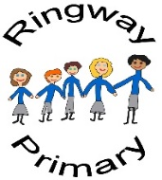
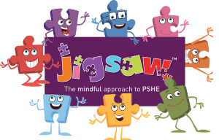
PSHE Knowledge Organiser
Overview
Key Vocabulary
Self-esteem | Trolls
Positive qualities | Online gaming
Admire | Screen time
Confidence | Effect
Online communities | Relationship
Social media | Technology
e-safety | SMART rules
Interests
Age restrictions
Fair use policy
To begin the unit the class will consider the personal qualities of a celebrity they admire before listing the positive qualities of one of their friends in the class. The qualities will be collated and shared before the class will discuss the concept of self-esteem. Then, teaching will focus on the varying kinds of online communities, encompassing a range of social media platforms, as well as considering the appropriate, legal at which said platforms should be accessed and how to stay safe online. Next, the class will consider online gaming specifically, including measuring the pros and cons of online gaming, applying their knowledge to a scenario while also considering the effects of prolonged screen time and their personal relationships with technology.

Social and Emotional Skills
- Can discuss their own personal qualities and those of their peers
- Can explain the concept of self-esteem and how compliments/insults can potentially impact this
- Is knowledgeable about varying websites and social media platforms
- Can discuss their own behaviour, and behaviours they have witnessed, while online

Knowledge
- Know about the personal qualities
- Know about self-esteem and how compliments/insults can impact self-esteem
- Know about various online communities and how to stay safe online
- Know how to report potential ‘trolls’ online
- Know about varying social media platforms, their age restrictions and fair use policies
- Know about varying forms on Online gaming to evaluate positive and negative aspects
- Know about their personal relationships with technology

