Quote
“It takes a great deal of bravery to stand up to our enemies, but just as much to stand up to our friends.”
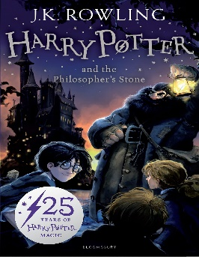
Knowledge Organiser – Harry Potter and the Philosopher’s Stone

Characters
Harry Potter | The main character, ‘The Boy who Lived’, who is already known by all witches and wizards despite having no magical experience.
Lord Voldemort | The main antagonist (villain) of the story, who is thought to be long-dead dark wizard.
Albus Dumbledore | The wise, kind and powerful Headteacher of Hogwarts.
Hermione Granger | A studious, highly-intelligent student at Hogwarts who soon becomes a close friend of Harry.
Ron Weasley | Harry’s first real friend at Hogwarts, Ron is a fellow Gryffindor from a magical family with many siblings.
Important Information
Plot Harry is an orphan living with his aunt, uncle and their son who frequently mistreat him. However, on his 11th birthday Harry receives an invitation to attend Hogwarts School of Witchcraft and Wizardry and learns that his parents were a witch and a wizard. Harry also learns that his parents did not die in a car accident but were murdered by a powerful dark wizard named Lord Voldemort from whom Harry is the only person to survive an attack.
Themes Confronting fears. Death. Love. Faith. Acceptance and tolerance. The value of humility.
Setting Little Whinging, Surry. London Zoo. King’s Cross Station. Hogwarts School of Witchcraft and Wizardry.

Grammar
Cohesion and Punctuation
Building cohesion into writing
Adverbials
Linking ideas across paragraphs
Text structure
Helping the reading

Brackets, dashes and commas
Using parenthesis in writing
Commas in writing
Revisiting Punctuation
Refining punctuation in writing
Key Vocabulary
Keen | (of a sense) highly developed (of an object) sharp
Trap door | A hinged or sliding entrance into a floor or ceiling
Appendage | A thing that is added or attached to something larger
Chortle | A soft, partly suppressed laugh
Bolt | To eat hastily without chewing
Incantation | A series of words said as part of a spell or charm
Mangle | (to) destroy of severely damage by tearing or crushing
