Quote
“Double, double toil and trouble; fire burn, and cauldron bubble.”
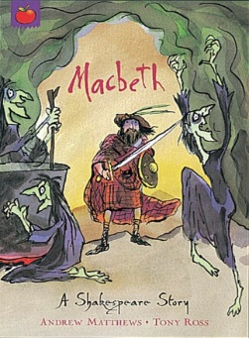
Knowledge Organiser – Macbeth

Characters
Macbeth | The main character and a captain in King Duncan’s army and the Thane of Glamis and Cawdor.
Lady Macbeth | Macbeth’s ambitious wife
Banquo | Macbeth’s close friend who also receives a prophecy from the witches
King Duncan | The popular, well-liked King of Scotland.
Macduff | The Thane of Fife who is loyal to King Duncan and suspicious of Macbeth.
Malcolm | King Duncan’s son and rightful heir.
The Witches | Three witches who give Macbeth and Banquo a prophecy following their victorious return from battle against the Norwegian forces.
Important Information
Plot Returning from battle against the Norwegian army, Macbeth and Banquo receive a prophecy from three witches outlining that Macbeth will soon be the King of Scotland. Macbeth soon becomes power-hungry and, encouraged by his wife, commits a terrible act of treason …

Themes Ambition. Appearance and reality. Guilt. Power. Chaos and disorder. Fate and free Will. Good and evil. The supernatural.
Setting Scotland in the 11th century. Macbeth’s Castle (in Inverness). Fife (home to Macduff). Dunsinane Castle.

Grammar
Clauses and Sentences
Revisiting clauses
What are relative pronouns and relative clauses?
Using relative clauses
Extending sentences using clauses
Clauses in writing
Key Vocabulary
Ambition | A strong desire to achieve something.
Apparitions | A ghost/ghost-like image of a person.
Masculinity | Qualities considered to be of a man.
Regicide | The action of killing a king.
Thane | A man with land granted by the king.
Tragedy | A play with tragic events.
Treason | The action of betraying one’s country
Virtuous | Having high moral standards.
