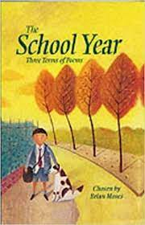 |  |  | Knowledge Organiser: The School Year, chosen by Brian Moses
 |  |  |  | Quote: “We’d never seen snow like it”
Themes |  |  |  |  |  |  |  |  |  | Important Information
School |  |  | New beginnings; |  |  |  |  |  |  | Poems use imagery to engage the reader or listener. They use all of the physical senses, not just what they can see. Language is chosen so that the imagination is sparked.
Seasonal events |  |  | Nature and festivals.
Weather |  |  | Interaction with different weathers. |  |  |  |  |  |  | Poems may seek to cause an emotional response. Language is chosen to try and help readers and listeners feel something through exposure to the poem.
Viewpoints |  |  | Contrasting ideas of events.
 |  |  |  |  |  |  |  |  |  | Nostalgia is an emotion that forms the basis of many poems. This is when happy memories help readers and listeners remember/feel the positive feelings from the past.
 |  |  | Grammar
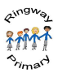 |  |  | Conjunctions, adverbs and prepositions to show time, place and cause.  Word classes/parts of speech.  Paragraphs, including organising them around a theme.
 |  |  |  |  |  |  |  |  |  | Key Vocabulary
 |  |  |  |  |  |  |  |  |  | Alliteration |  |  | When nearby words begin with the same sound.
 |  |  |  |  |  |  |  |  |  | Verse |  |  | A group of separate lines in a poem.
 |  |  |  |  |  |  |  |  |  | Simile |  |  | Used to describe something by comparing it to something familiar.

