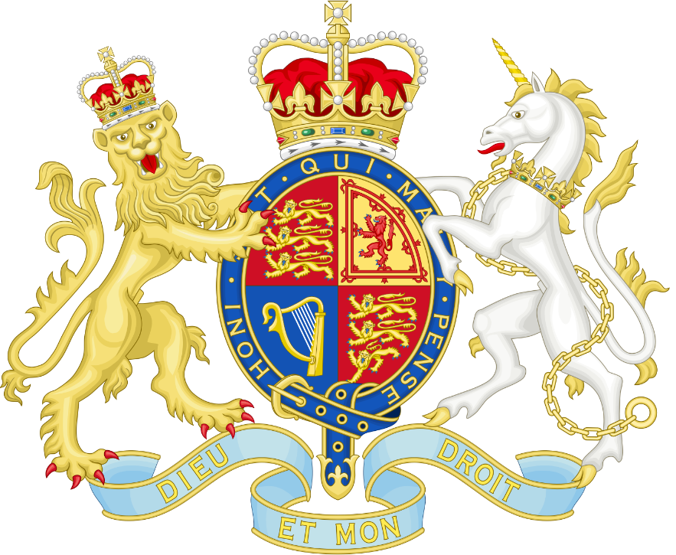

**Spanish**

The Weather and The Date

**R.E.**

What does it mean to be a Hindu in Britain today?

**English – English – The Lion, the Witch and the Wardrobe**

Writing

- Poetry

- Setting description

- Balanced argument

- Non- chronological report

Grammar

- Paragraphs

- Using possessive apostrophes

**Science – Electricity**

* Appliances
* Making circuits
* Completing circuits
* Conductors and Insulators
* Switches

**PSHE**

Dreams and Goals

**Design Technology**

Electrical Systems

**Art**

The development of perspective from medieval to renaissance

**Computing**

Photo editing

**Music**

Cornets

**PE – Dance (Wednesday)**

Cojo – Bear Grylls

**Maths**

Multiplication and Division

* Factor pairs
* Multiply and Divide by 10 and 100
* Written multiplication
* Written division

Length and Perimeter

* Kilometres and metres
* Perimeter of rectilinear shapes
* Perimeter of polygons

Fractions

* Count beyond 1
* Mixed numbers

**History – How has the power of monarchy changed since 1066?**

We will look at important events and significant monarchs throughout British history that have contributed towards creating Great Britain as we know it today.

These include:

* William the Conqueror and the Battle of Hastings in 1066
* King John and the creation of the Magna Carta
* Henry VIII and his break from Rome
* Queen Victoria and the British Empire
* The modern Royal family.

**How has the power of monarchy changed since 1066?**