Quote
“I disappeared the night before my twelfth birthday.”
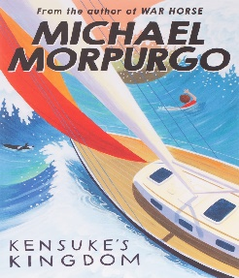
Knowledge Organiser – Kensuke’s Kingdom

Characters
Michael | The main character of the story
Stella Artois | Michael’s dog
Kensuke | Elderly Japanese man living on the island
Barnacle Bill | The old mariner who tutored the family to sail
Eddie | Michael’s best friend
Michael’s parents | Who taught him to sail and are his shipmates
Important Information
Plot When Michael’s parents lose tier jobs, they buy a boat and decide to sail around the world. Michael is swept overboard. He’s washed up on an island, where he struggles to survive. Then he discovers he’s not alone…

Themes Nature and environmental issues. Community and independence. Relationships between the old and the young. Mutual respect for and tolerance of those with different faiths and beliefs.
Setting Michael’s home. Aboard the Peggy Sue. An island in the Pacific Ocean.

Key Vocabulary
Brackish | (of water) slightly salty, as in river estuaries
Cacophony | A harsh discordant mixture of sounds
Flotsam | The wrecked of a ship found floating on or washed up by the sea
Gesticulate | The use of gestures, especially dramatic ones, instead of speaking
Mellifluous | (of a sound) pleasingly smooth and musical to hear
Obstinate | Stubbornly refusing to change one’s opinion
Outrigger | Beam, spar, or framework projection from or over a boat’s side
Grammar
Adjectives and Prepositions
Adjectives
Using adjectives
Prepositions
Using prepositions
Developing adjectives and prepositions

