PSHE Strand/ Year Group
Dreams and Goals – Year 5
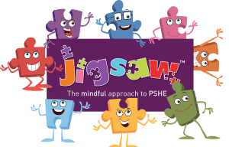
PSHE Knowledge Organiser
Overview
Key Vocabulary
Job | Kenya
Career | Charity
Salary
Wage
Steps to Success
Requirement
Education
Qualification
Degree
Trade
The class will consider their dream jobs, and potential careers, for the future. Then, they will research potential salaries of jobs that appeal to them and find out about the varying qualifications and experiences required for the positions. Then, the class will discuss and decide up on their steps to success that will enable them to reach their future goals before learning about the dreams and goals of children in other countries. Finally, the class will learn about varying charities and consider which they would be most likely to support.

Social and Emotional Skills
- Be ambitious regarding potential future careers
- Be inquisitive about the ideal careers of others
- Discuss potential challenges and obstacles
- Be open-minded and considerate to the needs of others
Knowledge
- Know about a range of jobs and careers
- Know about the potential salaries of varying jobs
- Know about some of the steps to success they could take in order to achieve their dream job or career
- Know about some of the dream jobs and goals of children in other countries
- Know about a range of charities

