PSHE Strand/ Year Group
Healthy Me – Year 5
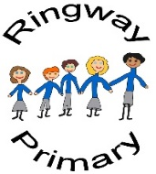
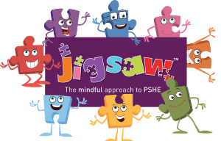
PSHE Knowledge Organiser
Overview
Key Vocabulary
Healthy | Recovery Position
Balanced diet | Body image
Active lifestyle | Similarities
Smoking | Differences
Harmful | Edited
Alcohol | Images
Drunk | Messages
Anti-Social Behaviour
Misuse
Emergency Aid
The class will learn about smoking and the negative impact it can have on health through studying the Tobacco Industry’s Poster Child before learning about alcohol and the potential impacts of anti-social behaviour. Next, the class will learn about emergency aid before practical learning opportunities centred around the Recovery Position. Finally, the class will then explore the concept of body image and how advertisements and Photoshop can influence images that are widely shared.

Social and Emotional Skills
- Can explain some of the negative impacts of smoking and alcohol consumption
- Can give examples of emergency aid and explain how to react in a given scenario
- Is able to demonstrate the Recovery Position
- Can discuss body image; including societal pressures to ‘look’ a certain way

Knowledge
- Know about the potential health impacts of smoking and drinking
- Know about a healthy lifestyle
- Know about emergency aid and when it may be required
- Know what the Recovery Position is and how to put someone I the Recovery Position
- Know about the concept of body image
- Know about the impact that Photoshop and other editing software can have on impacts
- Know about some of the core messages in food advertisements

