**What is magical about our local area?**

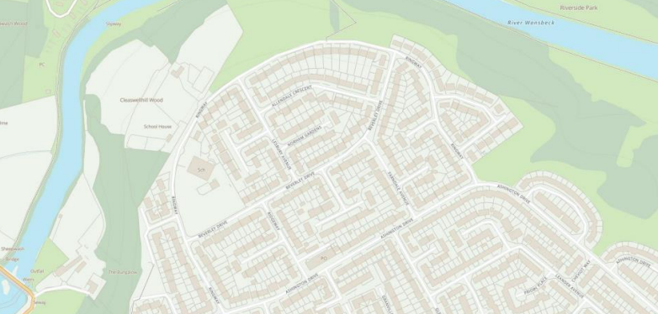

**Art - Hokusai**

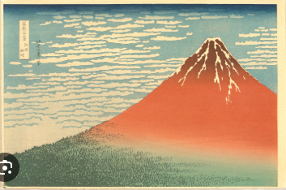

**Spanish – In the Classroom**

* What is in my pencil case?

**RE - For Christians, when Jesus left; what was the impact of Pentecost?**

**Music – Rock and Roll**

* Hand Jive
* Rock around the Clock
* Walking bass Line

**Computing – Repetition in games**

* Using loops to create shapes
* Different loops
* Animate your name

**PSHE – Relationships**

* Jealousy
* Love and Loss
* Friendships and relationships

**PE**

* Hockey (Tuesday)
* Swimming (Wednesday PM)

**Science – Living things and their habitats**

* Grouping organisms
* Classification Keys
* What living things can we find in _____ habitat
* Recognise habitats can change

**Geography – What could be magical about our local area?**

* Ordnance Survey maps
* Collecting data
* Observing the local area
* Presenting findings

**English - The Works**

**Writing**

* Different forms of poetry including haiku, limerick and couplets.

**Grammar**

* Pronouns
* Determiners

**Maths**

**Decimals**

* Compare and order
* Partition
* Rounding decimals

**Money**

* Write money as decimals
* Compare and estimate money