PSHE Strand/ Year Group
Being Me in My World – Year 5
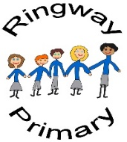
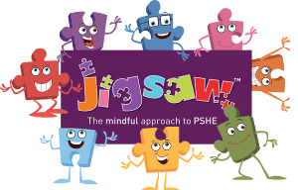
PSHE Knowledge Organiser
Overview
Key Vocabulary
Aims | Responsibilities
Targets | Rewards
Goals | Consequences
United Nations
Articles
Responsibilities
Asylum Seeker
Refugee
Class Charter
Rights
The children will analyse the school’s aims, as published on our website, before using these aims to inform goals set for the year on class and personal basis. Then, the class will learn about the UNCRC (United Nations on the Convention of the Rights of a Child) by examining the articles and discussing how they collectively define the rights of all children. Following this, the class will discuss how the responsibilities we all have in order to enable said rights, as well as how the rights apply to refugees and asylum seekers, before agreeing a Class Charter and appropriate rewards and consequences.

Social and Emotional Skills
- Be considerate and respectful of the ideas of others
- Share their ideas in a clear manner
- Discuss how the rights of all children outlined in the UNCRC can be applied
- Identify appropriate actions and possible consequences
Knowledge
- Know the school’s aims
- Know about the UNCRC
- Know about the different articles that makes the UNCRC
- Know about their rights and responsibilities
- Know how this applies to all children including refugees and asylum seekers
- Know about appropriate rewards and consequences

