PSHE Strand/ Year Group
Dreams and Goals - Reception
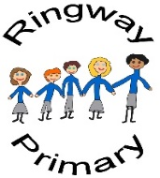
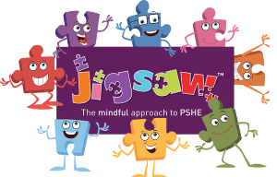
PSHE Knowledge Organiser
Overview
Key Vocabulary
Dream | A wish for the future
Goal | Something that you want to do, to be, or to have
Challenge | An achievable task or problem
Perseverance | To keep trying despite difficulties
Ambition | A desire to achieve a particular goal.
Achievement | To accomplish a goal or an activity
Job
Happy
Kind
Encourage
The children talk about challenges and facing up to them. They discuss not giving up and trying until they have achieved their goal. The children are encouraged to think about jobs that they might like to have when they are older and are taught to associate what they learn now with being able to have the job they want. They also talk about achieving goals and the feelings linked to this.

Social and Emotional Skills
- Understand that challenges can be difficult
- Recognise some of the feelings linked to perseverance
- Talk about a time they kept trying and achieved a goal
- Be ambitious
- Resilience
- Recognise how kind words encourage people
- Feel proud and celebrate success

Knowledge
- Know what a challenge is
- Know that it is important to keep trying
- Know what a goal is
- Know how to set goals and work toward them
- Know which words are kind
- Know some jobs they might like to do when they are older
- Know that they must work hard now in order to be able to achieve the job they want when they are older
- Know when they have achieved a goal

